

Computer Networks Lab
[ENCS352]

KR. MANGALAM UNIVERSITY
For
Bachelors in Technology
in
Computer Science and Engineering
With Specialisation AI & ML

SUBMITTED BY: SUBMITTED TO:
Upadhyayula Nijaagna Ms. Jyoti Kaurav
2301730196
Btech Cse AI & ML

S. No. | Experiment Title | Date | Page No. | Remarks / Sign
1 | (a) CPT Platform Overview  (b) Peer to Peer Network
2 | Network Topologies – (a) Star Topology
 | Network Topologies – (b) Ring Topology
 | Network Topologies – (c) Mesh Topology
 | Network Topologies – (d) Tree Topology
3 | (a) LAN using Hub
 | (b) LAN using Switch
4 | Tracert and Ping commands – Network Diagnostics
5 | (a) Designing the Network (CAN)
 | (b) Static IP Address Assignment to devices in the Network
6 | IP and Subnetting – IP Configuration
7 | Wireless Home Network – Router Configuration
8 | Capstone Project – End-to-End Network Design & Simulation

EXPERIMENT 1

(a): CPT PLATFORM OVERVIEW

Theory
Cisco Packet Tracer is a network simulation tool used to design and test network topologies without physical hardware. It provides a virtual environment with devices like routers, switches, and PCs. It helps students understand networking concepts. It supports both real-time and simulation modes. It is widely used for learning and experimentation.

Steps
- Open Cisco Packet Tracer.
- Observe workspace, device toolbar, and connections panel.
- Drag one PC and one switch.
- Connect them using a straight-through cable.
- Click on devices to explore Desktop and Config tabs.

Result
Successfully explored the Cisco Packet Tracer interface.

Conclusion
Packet Tracer provides an effective platform for learning networking concepts.

(b): PEER-TO-PEER NETWORK

Theory

A peer-to-peer network allows devices to communicate directly without a central server. Each device acts as both client and server. It is simple, cost-effective, and suitable for small networks. Data sharing can be done directly between devices. However, it lacks centralized control and security.

Steps
- Add two PCs (PC0, PC1).
- Connect using a cross-over cable.
- Assign IP addresses:
  - PC0 → 192.168.1.1
  - PC1 → 192.168.1.2
- Open Command Prompt on PC0.
- Run: ping 192.168.1.2

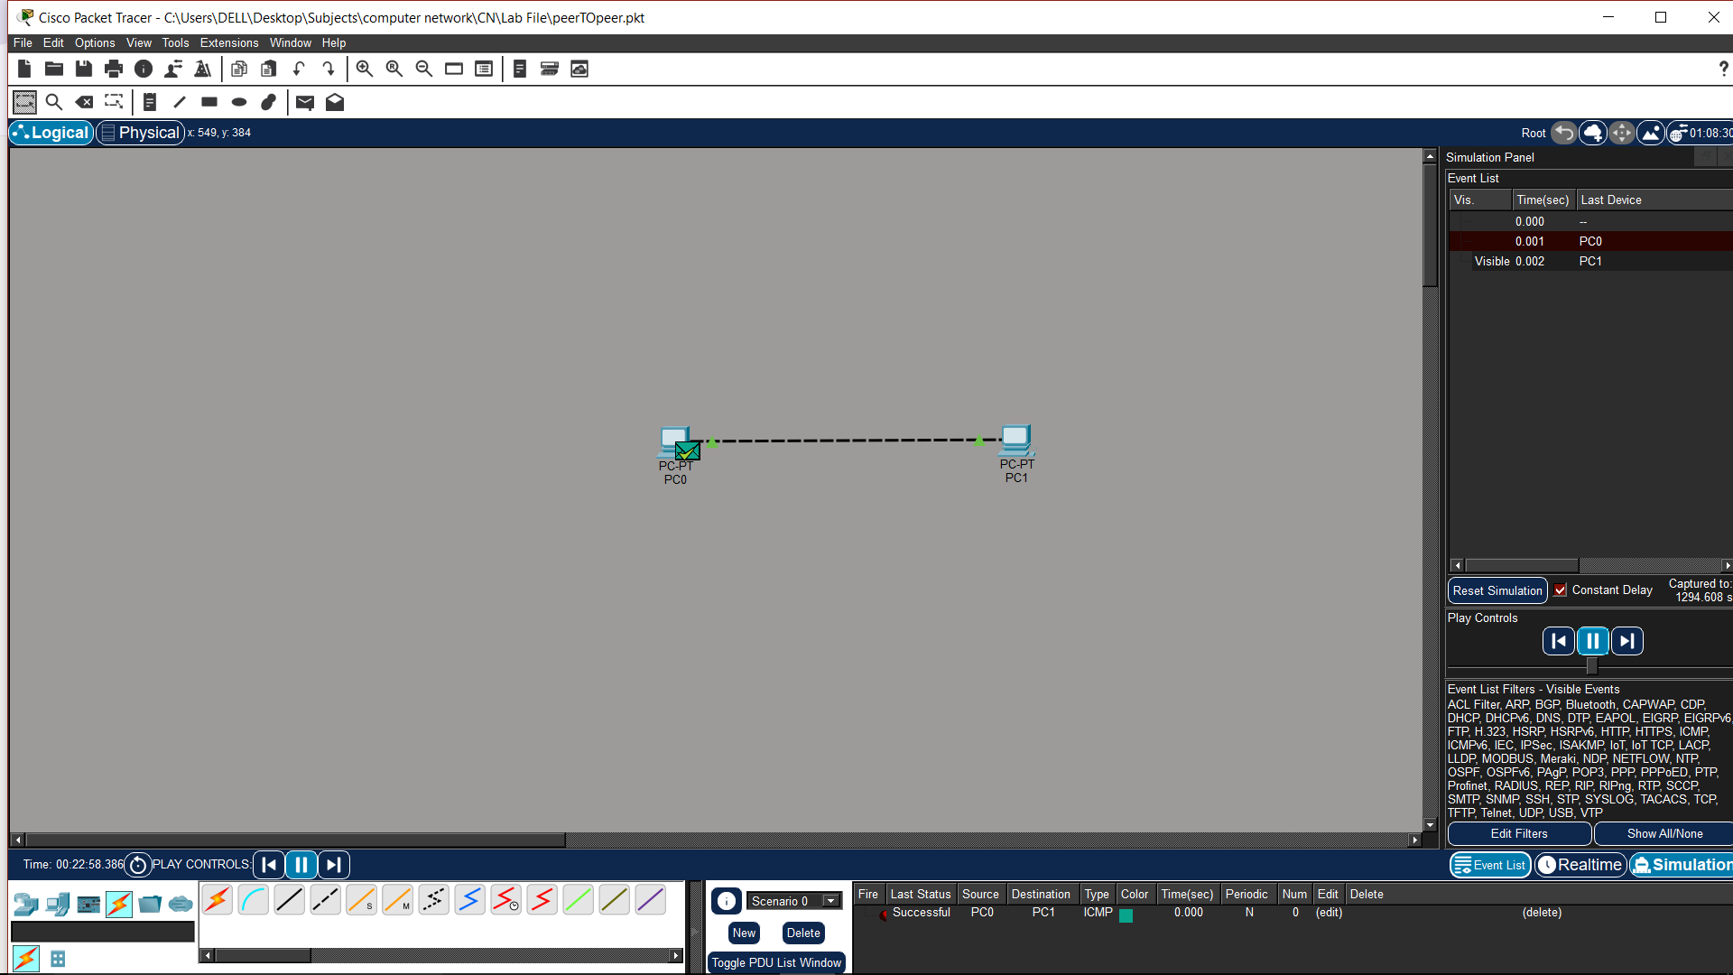

Result
Ping successful between PCs. Peer-to-peer communication was established successfully.

EXPERIMENT 2
(a): STAR TOPOLOGY

Theory
Star topology connects all devices to a central switch. All communication passes through this central device. It is easy to install and manage. Failure of one link does not affect others. However, failure of the central device stops the entire network.

Steps
- Add one switch and multiple PCs.
- Connect PCs to switch using straight cable.
- Assign IPs:
  - PC0 → 192.168.1.1
  - PC1 → 192.168.1.2
  - PC2 → 192.168.1.3
  - PC3 → 192.168.1.4
- Test using ping.
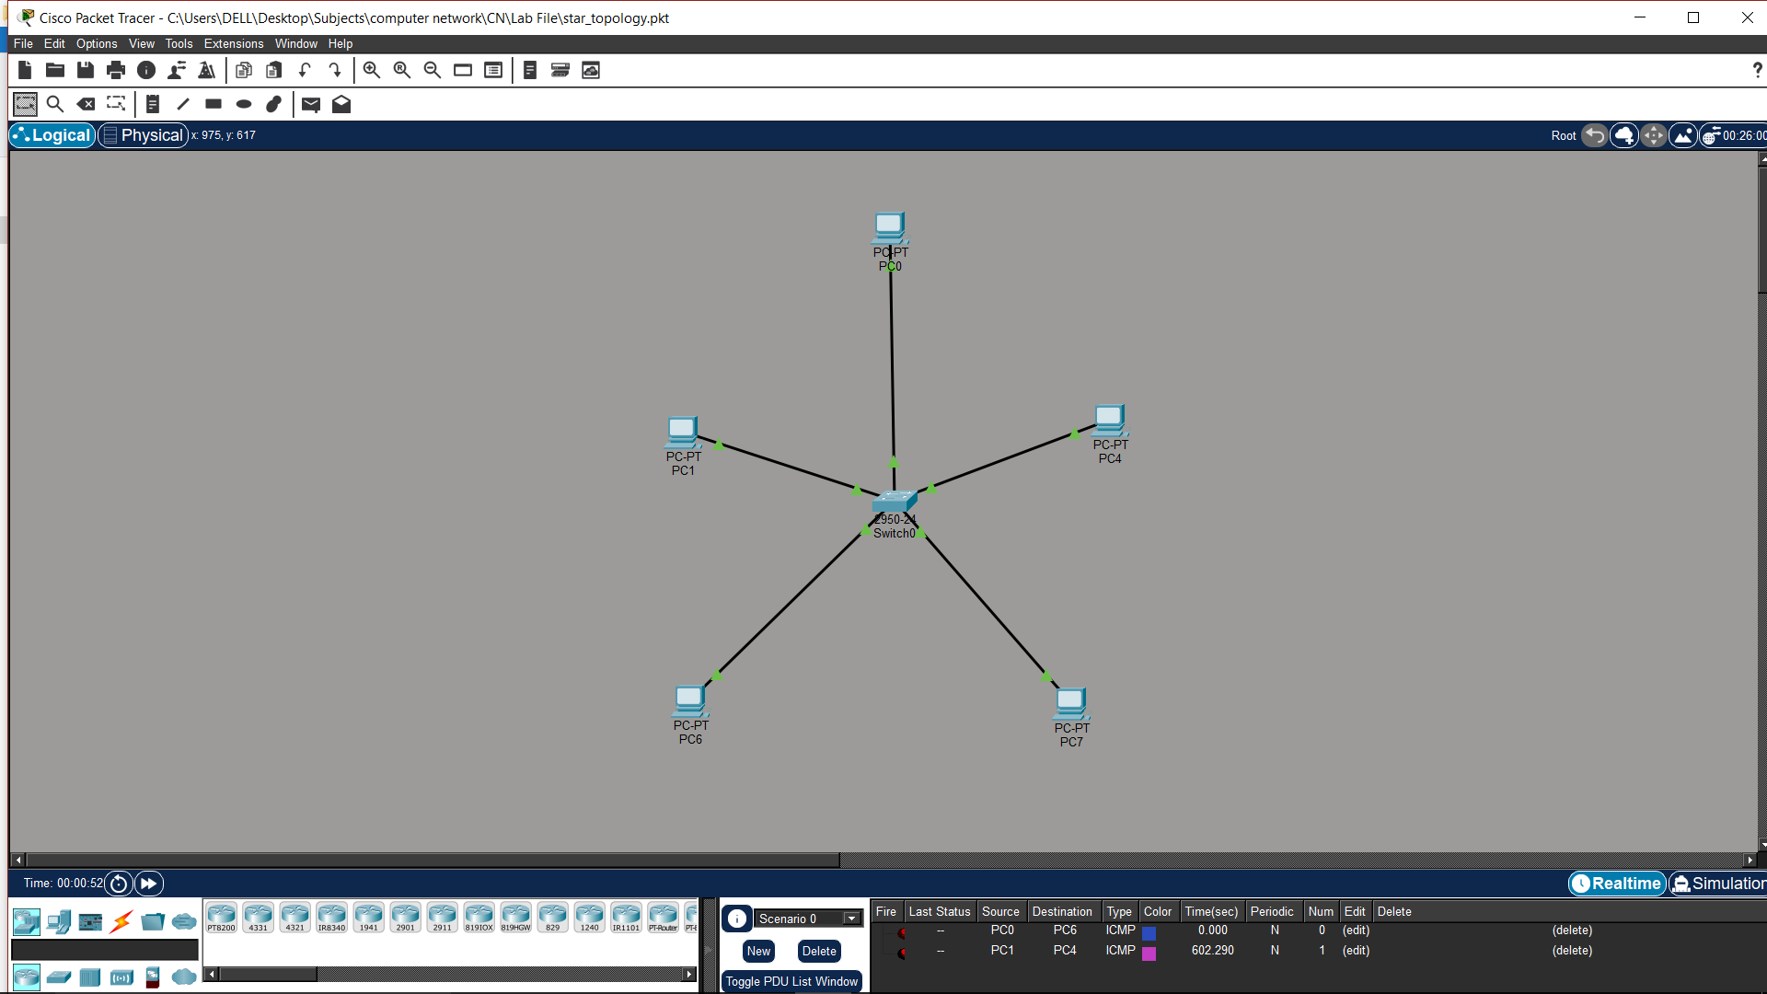

Result
All devices communicate through switch. Star topology is reliable and easy to troubleshoot.
(b): RING TOPOLOGY

Theory
Ring topology connects devices in a circular form where each node is connected to two others. Data travels in one direction around the ring. It ensures equal access to all nodes. However, failure of a single link can disrupt the entire network. It is less commonly used in modern networks.

Steps
- Add 4 PCs and 4 switches.
- Connect switches in circular form.
- Connect PCs to switches.
- Assign IPs:
  - PC0 → 192.168.1.1
  - PC1 → 192.168.1.2
  - PC2 → 192.168.1.3
  - PC3 → 192.168.1.4
- Test connectivity using ping.
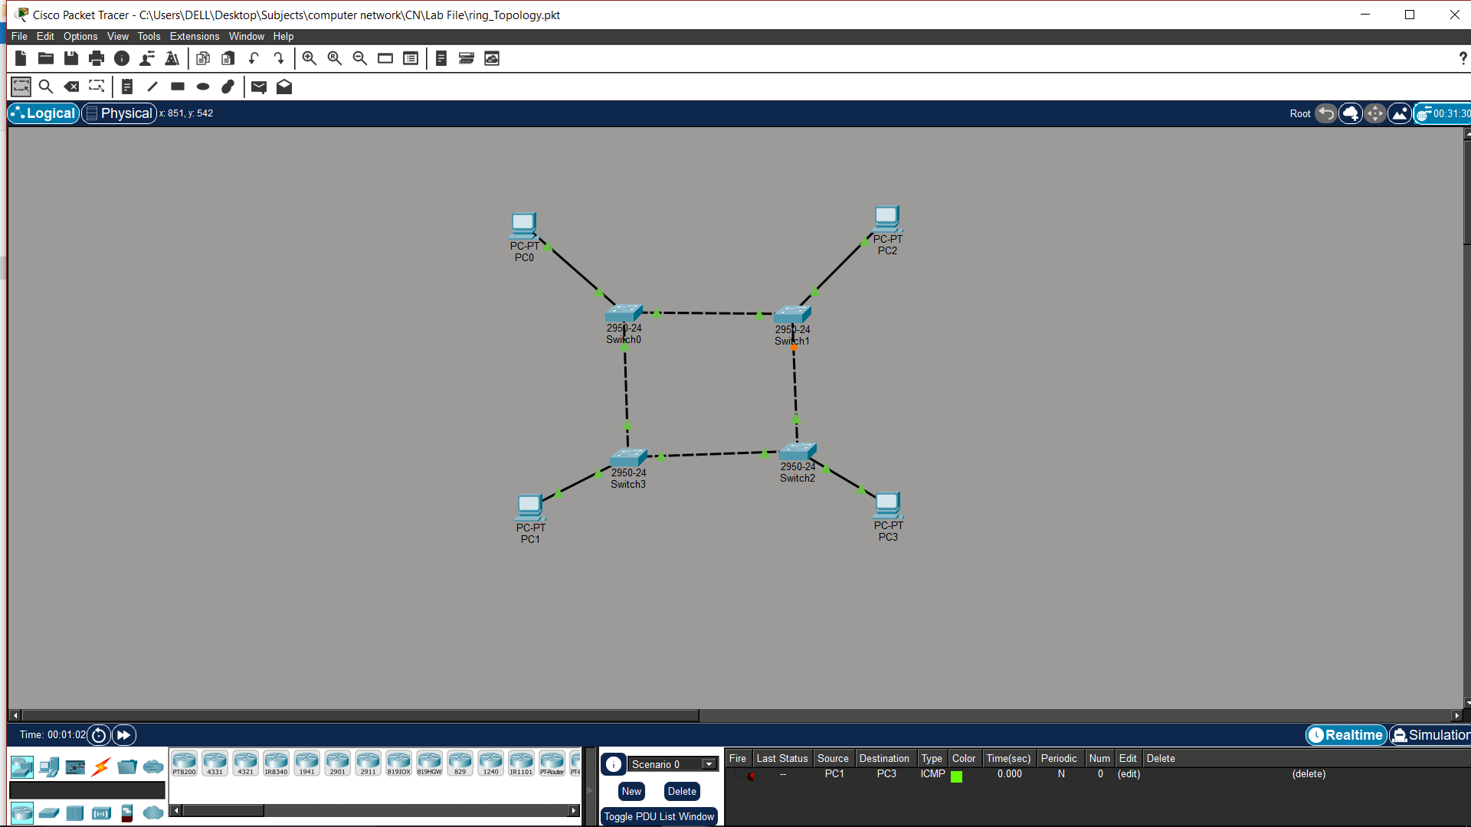

Result
Communication is successful in ring structure. Ring topology works but is less reliable than star.
(c): MESH TOPOLOGY

Theory
Mesh topology connects every device to every other device. It provides multiple paths for data transmission. This increases reliability and fault tolerance. Even if one path fails, communication continues. However, it is expensive and complex to implement.

Steps
- Add switches and PCs.
- Connect each switch with every other switch.
- Connect PCs to switches.
- Assign IPs:
  - PC0 → 192.168.1.1
  - PC1 → 192.168.1.2
  - PC2 → 192.168.1.3
  - PC3 → 192.168.1.4
- Test using ping.
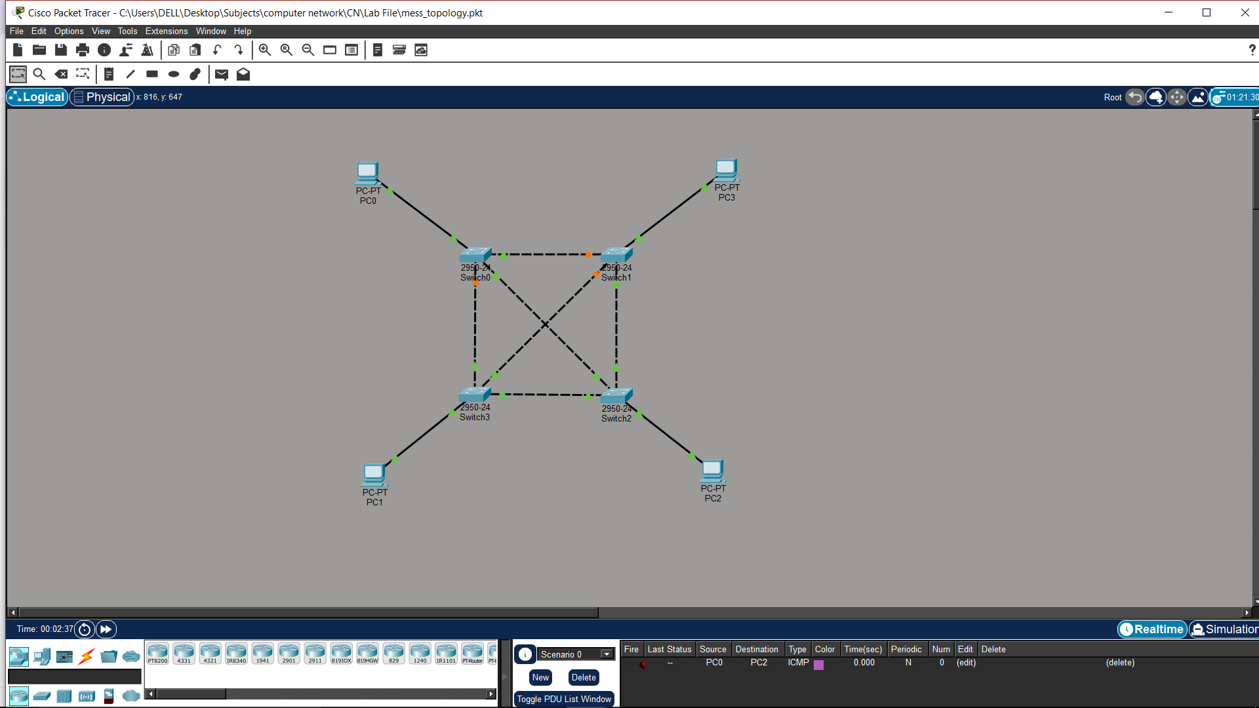

Result
Multiple communication paths are established. Mesh topology provides high reliability.

(d): TREE TOPOLOGY

Theory
Tree topology is a hierarchical network structure combining multiple star topologies. It has a root node and multiple levels. It is suitable for large networks. It allows for easy expansion and management. However, failure of backbone can affect the entire network.

Steps
- Add multiple switches in hierarchy.
- Connect switches in parent-child structure.
- Connect PCs to switches.
- Assign IPs:
  - PC0 → 192.168.1.1
  - PC1 → 192.168.1.2
  - PC2 → 192.168.1.3
  - PC3 → 192.168.1.4
  - PC4 → 192.168.1.5
  - PC5 → 192.168.1.6
- Test connectivity.
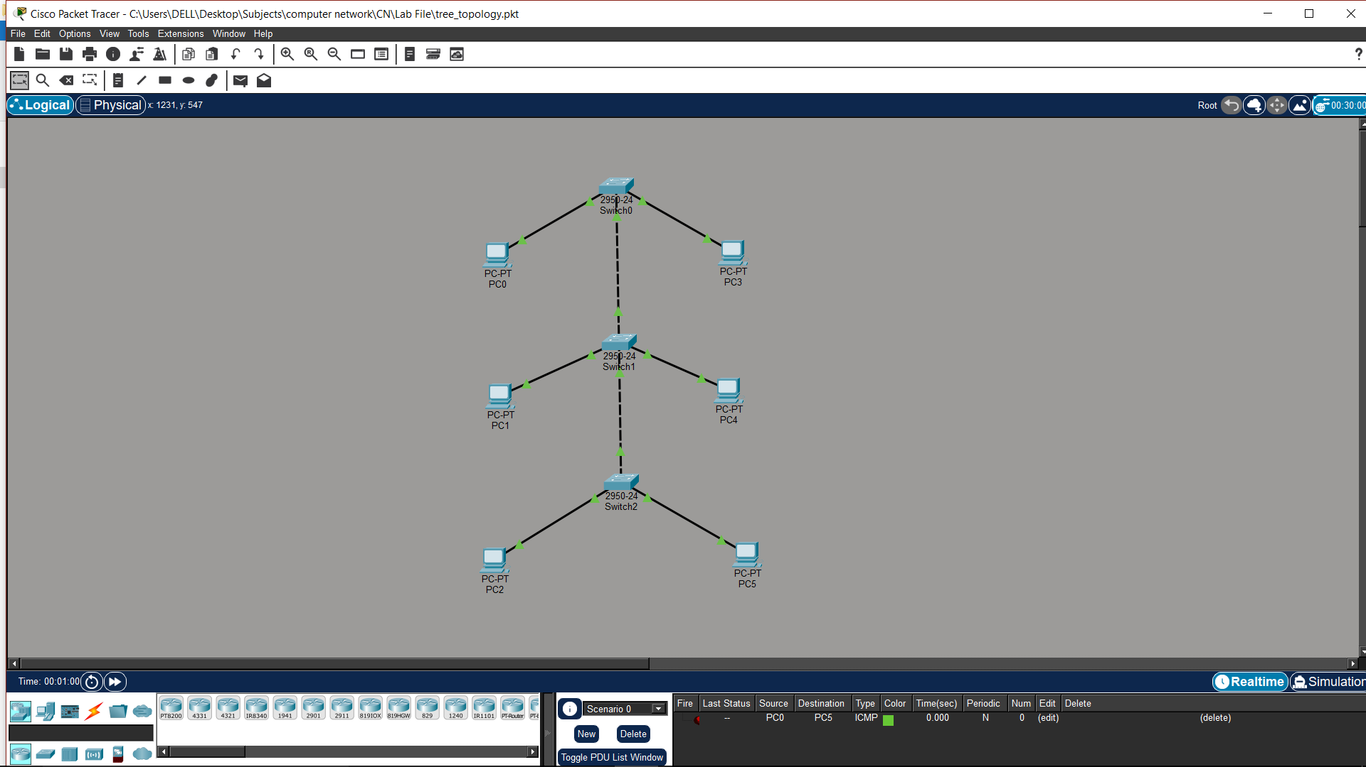

Result
Hierarchical communication was established. Tree topology is scalable and efficient.

EXPERIMENT 3
(a): LAN USING HUB

Theory
A hub is a basic networking device that broadcasts data to all connected devices. It operates on the physical layer. It does not filter data, leading to collisions. It is simple but inefficient. It is mostly replaced by switches.

Steps
- Add one hub and three PCs.
- Connect PCs to hub.
- Assign IPs:
  - PC0 → 192.168.1.1
  - PC1 → 192.168.1.2
  - PC2 → 192.168.1.3
- Test using ping.
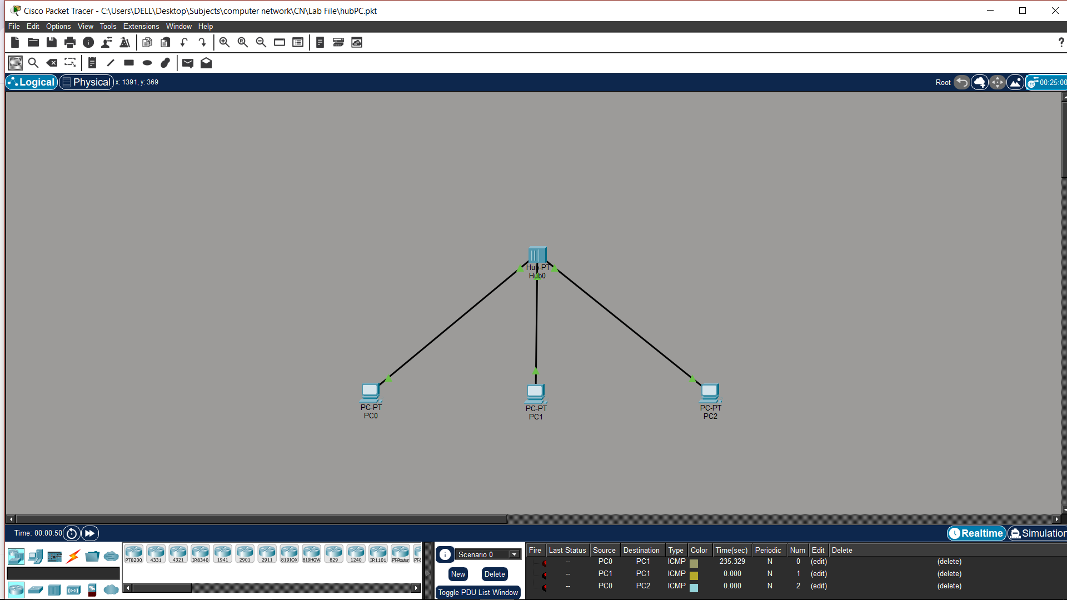

Result
All devices receive transmitted data. Hub-based LAN is inefficient due to broadcasting.

(b): LAN USING SWITCH

Theory
A switch is a networking device that forwards data only to the destination device. It operates on the data link layer. It reduces collisions and improves performance. It uses MAC address tables for efficient communication. It is widely used in LANs.

Steps
- Add one switch and multiple PCs.
- Connect PCs to switch.
- Assign IPs:
  - PC3 → 192.168.1.1
  - PC4 → 192.168.1.2
  - PC5 → 192.168.1.3
  - PC6 → 192.168.1.4
- Test connectivity.
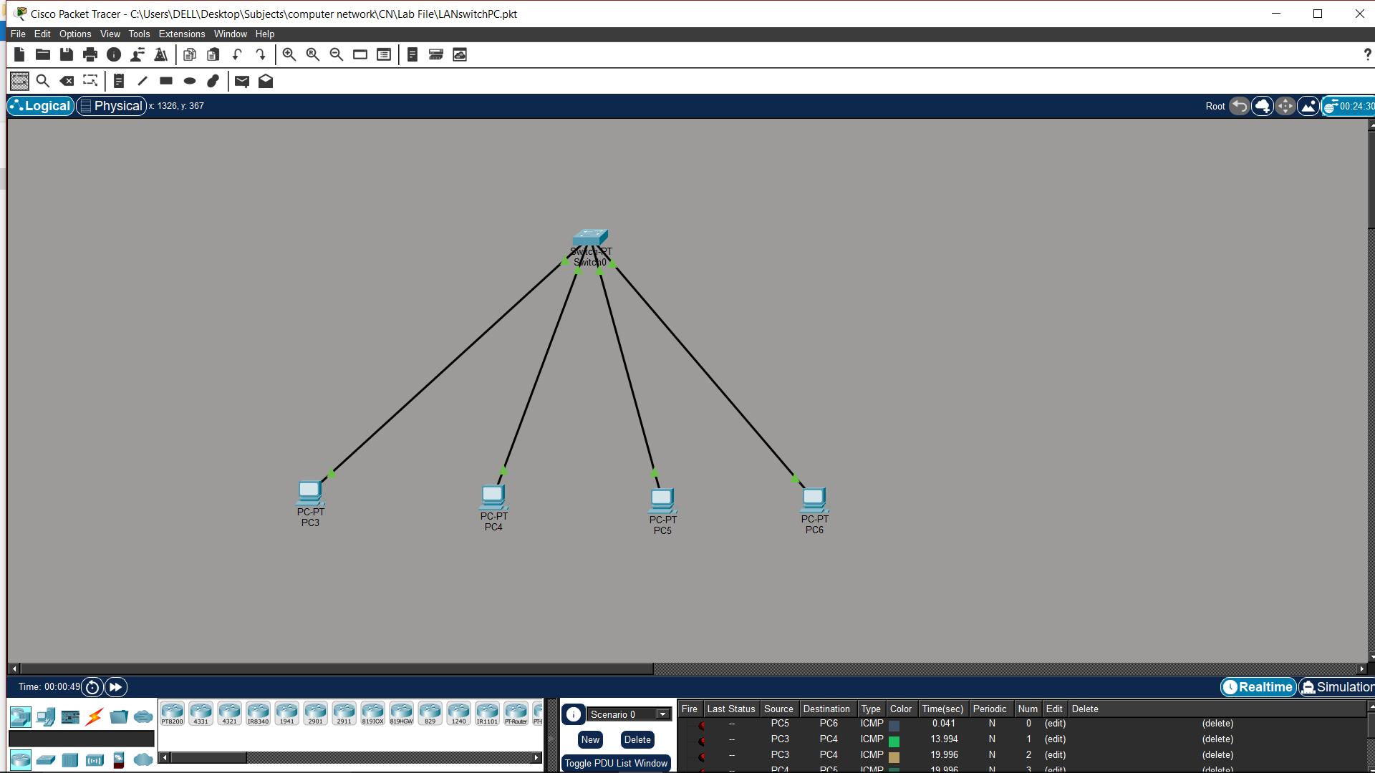

Result
Efficient communication is achieved. Switches improve network performance.

EXPERIMENT 4
PING & TRACERT

Theory
Ping is used to test connectivity between devices using the ICMP protocol. Tracert shows the path taken by packets. These tools help troubleshoot network issues. They provide information about delays and failures. They are essential diagnostic tools.

Steps
- Add router, switch, and PCs.
- Connect devices properly.
- Assign IPs:
  - PC0 → 192.168.1.1
  - PC1 → 192.168.1.2
  - Router → 192.168.1.254
- Set gateway in PCs → 192.168.1.254
- Run ping and tracert commands.
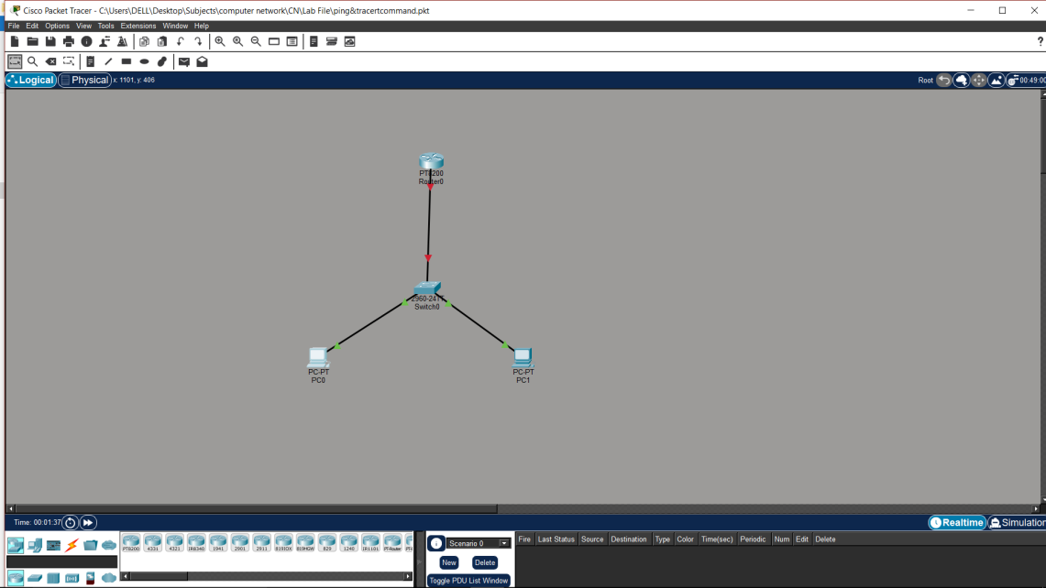

Result
Connectivity and path verified successfully. Ping and tracert help diagnose network problems.

EXPERIMENT 5

CAMPUS AREA NETWORK (CAN)

Theory
A Campus Area Network connects multiple LANs across buildings. It includes routers, switches, and servers. It allows communication between departments.

Steps
- Add router, multilayer switch, switches, PCs, servers.
- Divide network into departments.
- Connect all switches to central switch.
- Assign IPs:
  - ADMIN → 192.168.1.1
  - HR → 192.168.2.1
  - FINANCE → 192.168.3.1
  - BUSINESS → 192.168.4.1
  - E&C → 192.168.5.1
  - A&D → 192.168.6.1
  - STUDENT LAB → 192.168.7.1
- Set gateways → 192.168.X.254
- Test communication.
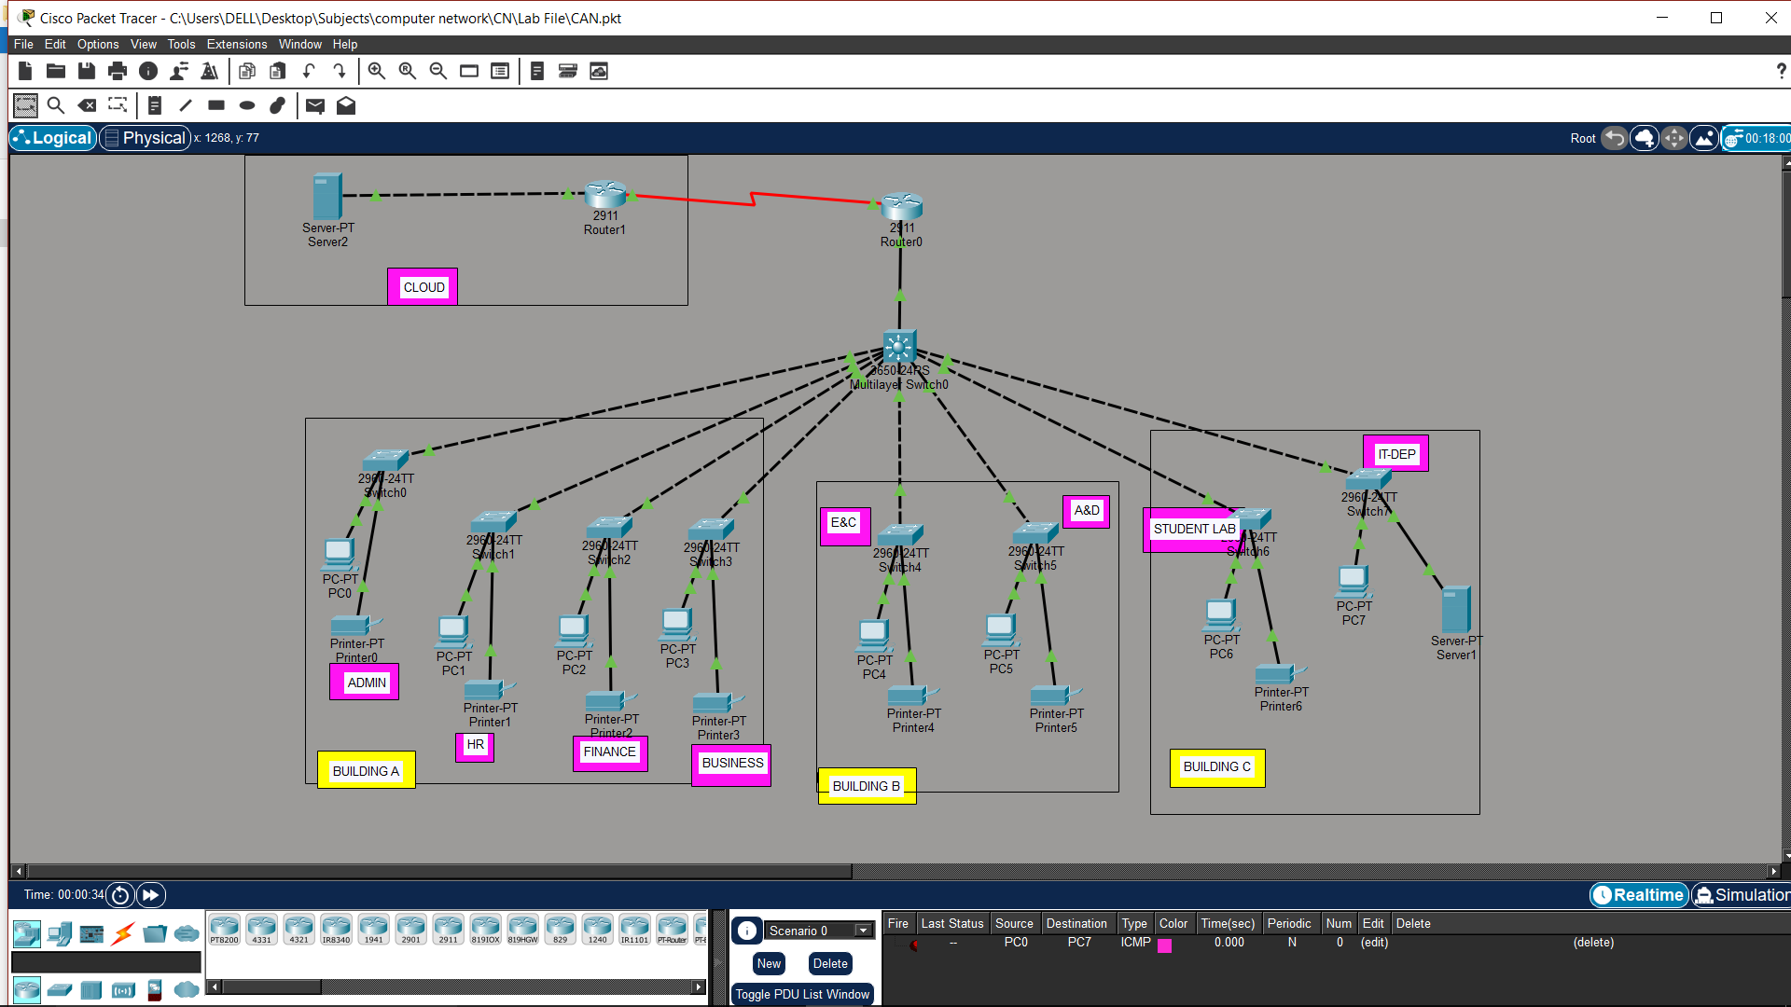
Result - All departments connected successfully. CAN enables efficient campus-wide communication.
EXPERIMENT 6
IP CONFIGURATION & SUBNETTING

Theory
IP addressing uniquely identifies devices in a network. Subnetting divides a large network into smaller subnetworks. It improves performance and security. Each subnet has its own range. It reduces congestion and improves management.

Steps
- Add router, switches, and PCs.
- Divide network:
  - Subnet1 → 192.168.1.0/25
  - Subnet2 → 192.168.1.128/25
- Assign IPs accordingly.
- Configure router interfaces.
- Set the gateways.
- Test connectivity.
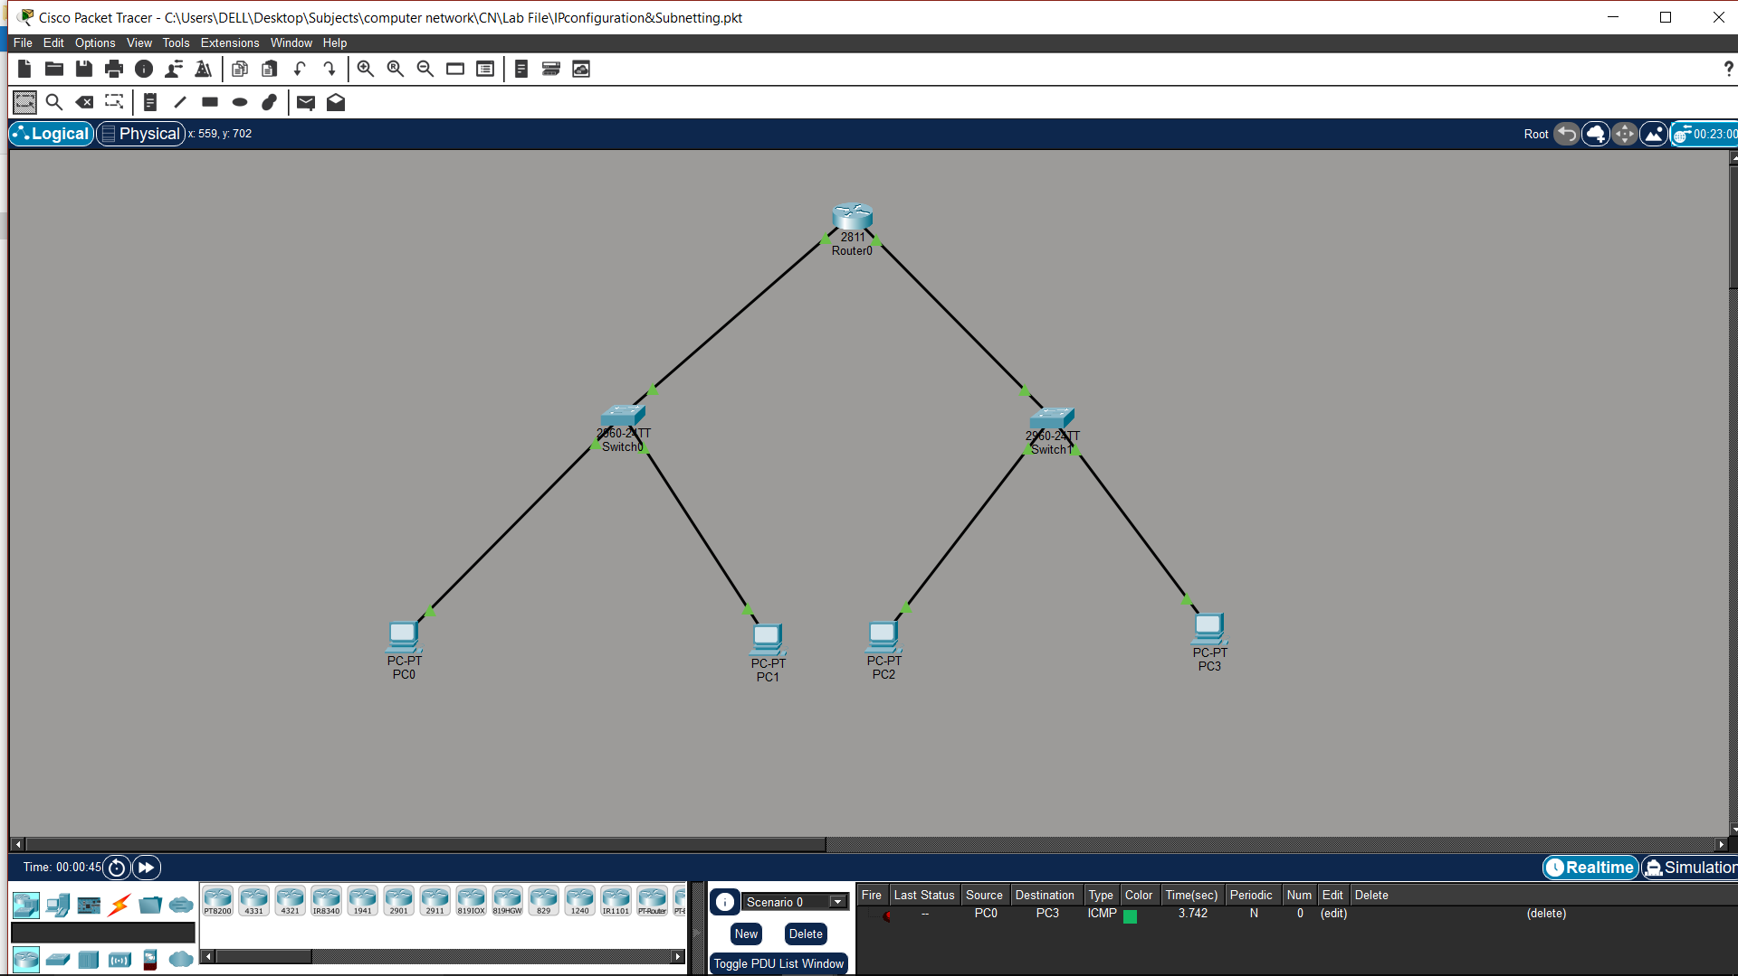

Result
Subnetted network works correctly. Subnetting improves efficiency and organization.
EXPERIMENT 7

WIRELESS NETWORK

Theory
Wireless networks connect devices without cables using radio signals. A wireless router provides connectivity through SSID. Devices like laptops connect using Wi-Fi. It provides flexibility and mobility. It is widely used in homes and offices.

Steps
- Add wireless router and laptops.
- Configure SSID and password.
- Connect laptops wirelessly.
- Assign IPs:
  - Router → 192.168.0.1
  - Laptop0 → 192.168.0.2
  - Laptop1 → 192.168.0.3
- Test connectivity.
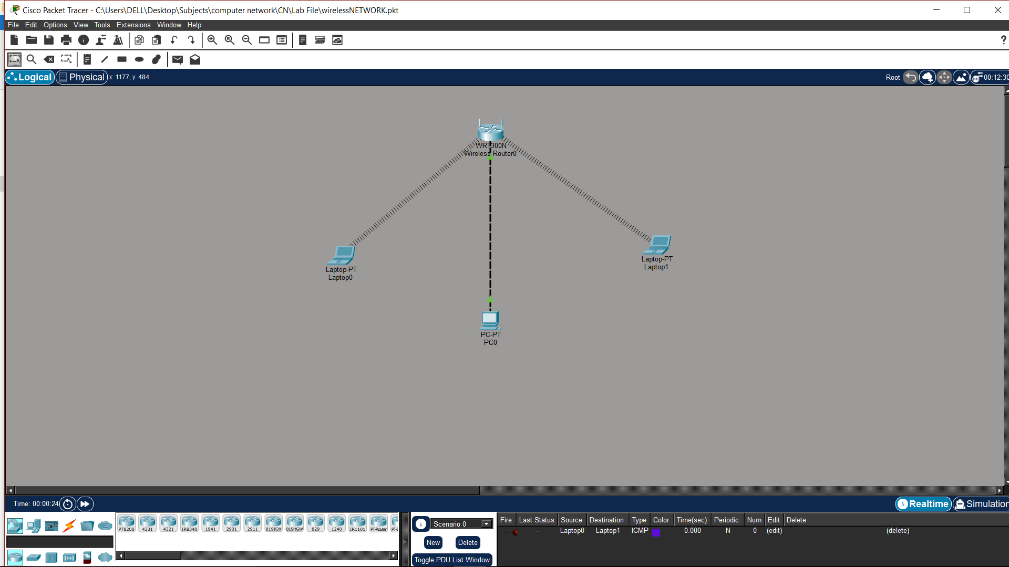
Result
Wireless communication is established. Wireless networks provide flexibility and ease of use.

EXPERIMENT 8
CAPSTONE PROJECT
Theory
A Wireless University Campus Network is designed to provide seamless connectivity across multiple departments and buildings using both wired and wireless technologies. It integrates networking concepts like VLANs, wireless access points, routing, and IP addressing for efficient communication. In this project, both main campus and branch campus are connected using routers. Wireless Access Points are used to provide Wi-Fi connectivity to users such as students, faculty, and staff. VLANs are used to logically separate departments. Technologies like DHCP, inter-VLAN routing, WAN connectivity, and secure wireless communication are implemented to simulate a real-world university network.
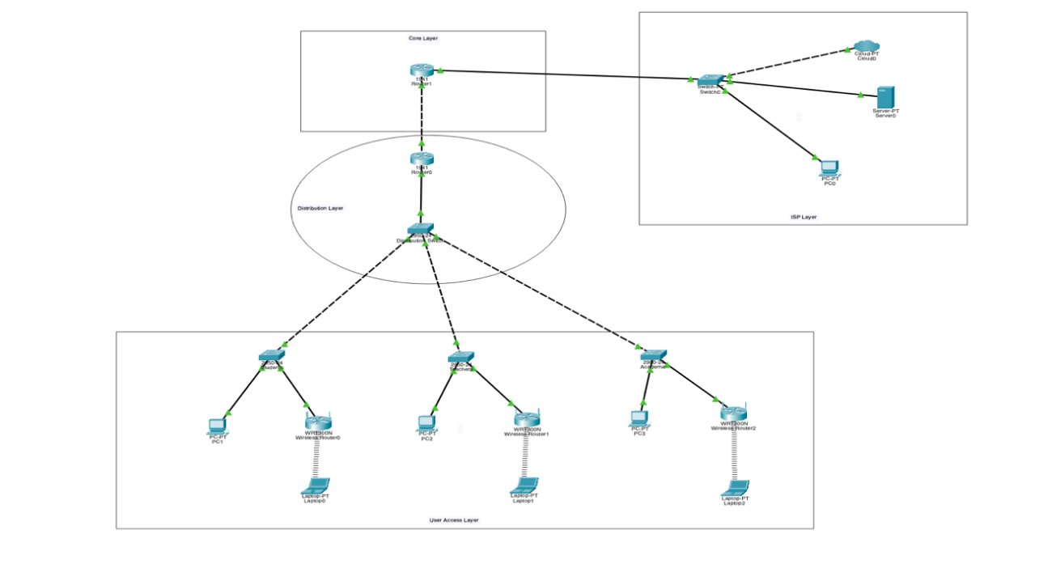

Steps
- Open Cisco Packet Tracer and create two networks: Main Campus and Branch Campus.
- Add devices:
a. 2 Routers
b. 1 Layer 3 Switch
c. Multiple Layer 2 Switches
d. PCs, Laptops, Printers, Servers
e. Wireless Access Points
- Connect devices using cables:
a. Straight-through → PC/Laptop to Switch, Switch to Router
b. Cross-over → Switch to Switch
c. Serial cable → Router to Router
d. Wireless connection → Devices connect to Access Point via Wi-Fi
- Configure VLANs for different departments:
a. VLAN 10 → 192.168.1.0/24
b. VLAN 20 → 192.168.2.0/24
c. VLAN 30 → 192.168.3.0/24
d. VLAN 40 → 192.168.4.0/24
e. VLAN 50 → 192.168.5.0/24
f. VLAN 60 → 192.168.6.0/24
g. VLAN 70 → 192.168.7.0/24
h. VLAN 80 → 192.168.8.0/24
i. VLAN 90 → 192.168.9.0/24
j. VLAN 100 → 192.168.10.0/24
- Assign IP addressing:
a. Subnet mask: 255.255.255.0 (/24)
b. Default gateway: 192.168.X.1
- Configure Wireless Network:
a. Create SSIDs (Campus-WiFi, Faculty-WiFi, Guest-WiFi)
b. Map SSIDs to VLANs
c. Enable security (WPA2/WPA3)
- Configure Inter-VLAN Routing using Layer 3 Switch.
- Configure DHCP server to assign IP automatically to wired and wireless devices.
- Configure WAN link between routers:
a. Network: 10.10.10.0/30
- Configure Static Routing between routers.
- Test network:
• Ping between VLANs
• Ping between campuses
• Connect wireless devices to Wi-Fi
• Access servers
Devices Used
• 2 Routers
• 1 Layer 3 Switch
• 9 Layer 2 Switches
• Wireless Access Points
• 11 PCs
• Wireless Laptops/Mobile devices
• 8 Printers
• 3 Servers
Protocols Used
• IP
• TCP/UDP
• HTTP, FTP, SMTP
• ARP, ICMP
• Static Routing
• IEEE 802.1Q
• IEEE 802.11
Features Implemented
• VLAN Segmentation
• Inter-VLAN Routing
• DHCP
• WAN Connectivity
• Wireless Communication
• Secure Wi-Fi Access
• Server Access
Result
The Wireless University Campus Network Design was successfully implemented, demonstrating real-world networking concepts like VLANs, wireless communication, routing, and WAN connectivity.

